RCS Daily Operations

Table of Contents
1. Postman 2
Ticket Creation 2
Fetch Emails to RCS Tickets 2
Redirect Emails to Internal Teams 2
Assign Emails to Internal Teams 3
Customer Escalation 3
2. Ticket Handling 3
Request Ticket 4
Incident Ticket 4
3. Ticket Follow-up 4
Appendix. MNOC Operation 5
Postman 5

Postman

Ticket Creation
Monitor RCS postman (formerly SD postman) and create new tickets for unassigned emails under RCS resource by default.
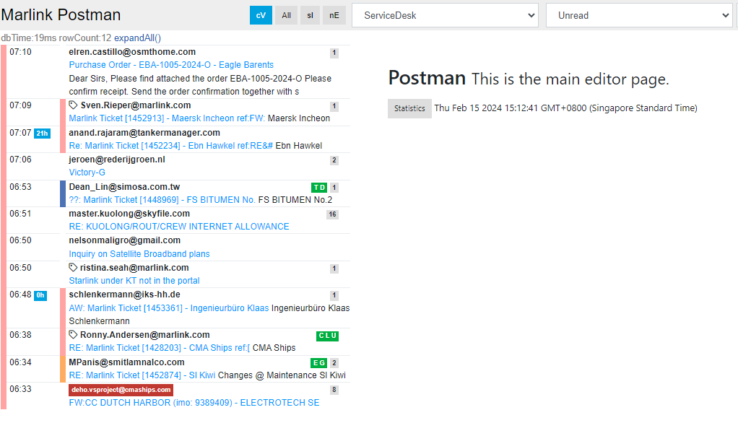

Fetch Emails to RCS Tickets
Monitor RCS postman and fetch emails to existing RCS tickets. Color code: pink

Redirect Emails to Internal Teams
If an email is addressed to another internal team, and they are not in the email loop, we can forward to them by below:
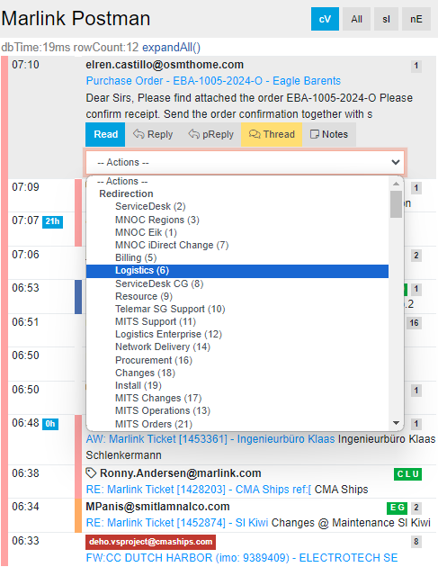

Assign Emails to Internal Teams
If the ticket is already assigned to another team, e.g., MNOC Bratislava, CCTS etc., we should assign the email to them.
Note: the difference between Redirection and Assign is:
Redirection= forwarding an email to an email address, e.g., resource@marlink.com
Assign= assign an email to a resource, who shares the same service desk email with RCS, e.g., MNOC Bratislava and CCTS
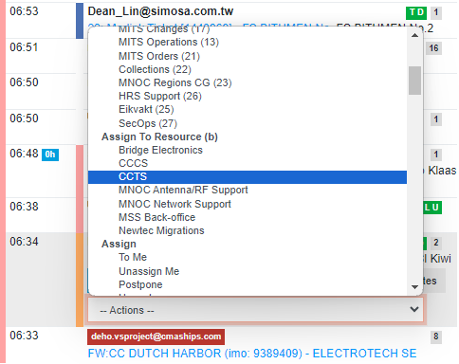

Customer Escalation
Email to escalation@marlink.com is automatically forwarded to RCS postman. RCS team shall acknowledge on the reception to customer, and forward it to the relevant team.

Ticket Handling
RCS team should utilize RCS dashboard to handle the tickets. Filters to be applied: ALL RCS centers, RCS (formerly Service Desk) resource, “In progress” status. Tickets to be sorted in the order of “last action”.

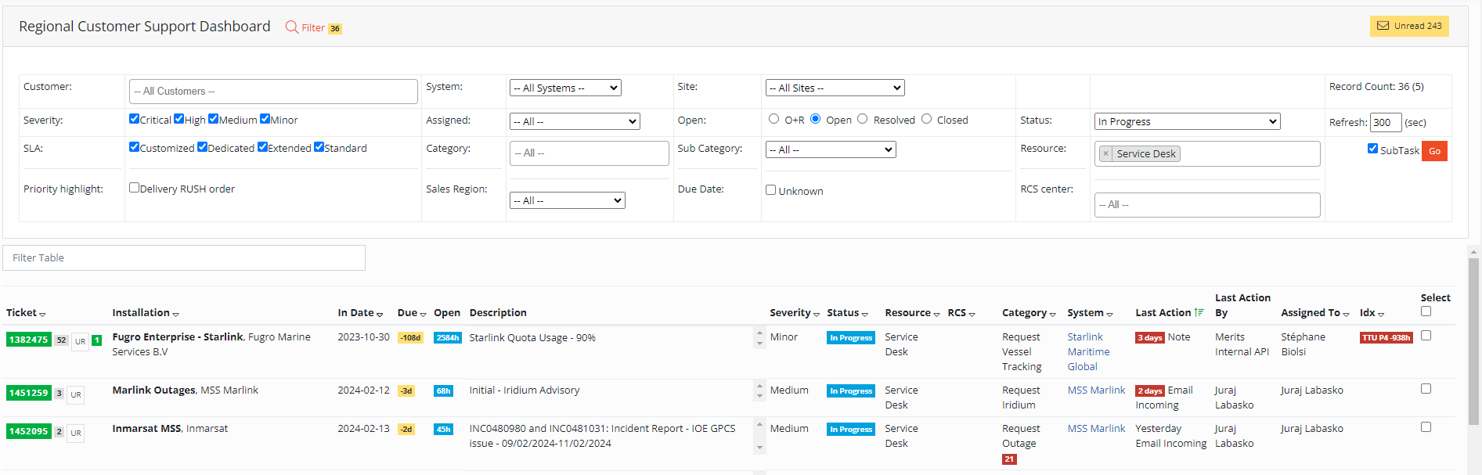

Tickets status must be updated afterwards, e.g., to “waiting for customer”. We should set “auto close” when there is a good chance that customer may not reply to us, e.g., after a beam switching and blockage check.
Key findings in troubleshooting should be captured in ticket notes.

Request Ticket
RCS should validate that customer has provided the necessary information for activation and deactivation tasks, then forward the ticket to Backoffice team.

Incident Ticket
RCS should follow the scope as defined in Excel matrix, and fulfil the minimum work required before escalating to MNOC Bratislava.​

Ticket Follow-up
RCS team should follow up on the open tickets under their corresponding region.
Filters to be applied: RCS center, “incident” “Request” category, ALL resource, “In progress” status.

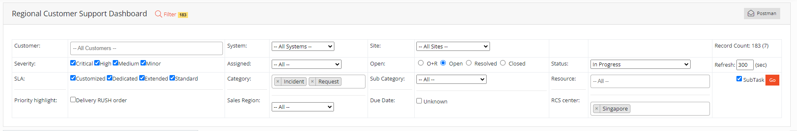

Appendix. MNOC Operation
During the transition period, SG and US RCS teams will continue to function as rMNOC, outside MNOC Bratislava’s office hours.

Postman
Select “MNOC Regions VSAT Support” filter in postman, and work on the emails on first-in-first-out basis.
